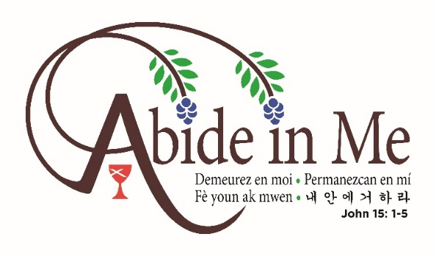

2019 General Assembly, July 20-24
Des Moines, Iowa

GA Promotional Sundays Worship Material

Call to Worship #1
One: Christ is the Vine
Many: We are the Branches
One: Christ calls us to abide in him, so that we may bear fruit
Many: Fruit of love and compassion, justice and faith
One: So that all may know that God is a god of Life
Many: This morning and all mornings may we celebrate God and abide in Christ

Call to Worship #2
One: We are called to abide in Christ,
Many: To offer comfort and care.
One: We are called to abide in Christ,
Many: To listen and love.
One: We are called to abide in Christ,
Many: So that all may know God’s love.
One: Through our words and actions,
Many: May all know we abide in Christ.

Communion Meditation and Prayer #1
Have you seen a wild grape vine? It’s twisted and bushy and for the most part looks like a weed. It often doesn’t match what we think of when we imagine a grapevine to look like. Yet, without God as the vine grower giving us a direction and roots to grow and Christ as the vine giving us strength to bear fruit of compassion, justice, faith, and love. As Disciples, this table is one of our grounding practices. It connects us with God and reminds us of the Christian community of which we are all a part. This meal gives us nourishment to live into our call to be a movement for wholeness and a place for which we abide in Christ. May this meal remind us of Christ’s sacrifice and resurrection, that in Christ we may abide and bear fruit.

Let us pray: May this bread and cup give us strength to serve your world. May this meal remind us of the fruit we are called to bear, as individuals, local church communities, and as the Christian Church (Disciples of Christ). For your son the vine in whom we abide, we give you thanks, O God, the life-giver and vine grower. Amen

Communion Meditation and Prayer #2
As Disciples, we recognize the importance of this meal as a time to remember the saints who have gone before us, celebrate the community here now, and look forward to the time when we all abide in Christ in heaven and on Earth. To abide means to endure, to continue to be present, to journey with. At this table and with this meal, we are reminded of Christ’s enduring presence, his death and his resurrection. With this meal, we are given tangible pieces for our own journey, to abide in Christ always and to share his message of abundant life so that all may know God’s unconditional love.

Let us pray: Holy God, for your presence and faithfulness we give you thanks and praise. Bless this sacred meal. May it give us strength to continue to live out the call you have given us, may it remind us to abide with you, may it offer hope and a symbol of your constant love. Amen

Pastoral Prayer #1
Holy One, who sent your Son to walk among us and who asks us to abide in him, we give you thanks for your constant presence and unending love. Continue to be with those who need you the most, those grieving, those in need of healing, those whose situations may feel overwhelming. Give us strength to go out into the world and serve our brothers and sisters. May we abide with them as Christ abides with us. For the world so desperately needs it and it is what you call us to do. May we be instruments of your peace, bearers of your fruit, and lamps to shine your light. In your son’s name we pray, Amen.

Pastoral Prayer #2
Life-giving God, in whom Christ Jesus is the true vine, we confess that we have not always bore the fruit of compassion and love you have asked us to. We have turned the other way and ignored brothers and sisters in need. We have remained silent when injustice has roared from the sidelines. We have sometimes thought that we could bear fruit on our own and neglected and ignored the vine from which we stem. Forgive us O God. Help us listen closely for your voice. Give us strength to continue to abide in you—to journey with you, to live out the call to be a movement for wholeness. For all that you have given us, God of life, we give you thanks and praise. May we bear the good fruit Christ calls us to bear, Amen.

Hymns:
God is Here (280)
Abide in Me (636)
Many are the Lightbeams (492)
Be Thou My Vision (595)
I Bind My Heart This Tide (350)
These I Lay Down (391)
Seed, Scattered and Sown (395)
Be Known to Us in Breaking Bread (398)

